MEMORANDUM

1. Purpose
This memorandum summarizes the methodology, data sources, and evaluation results of a study assessing the quality of Statt-generated public regulatory comments. The primary analysis (Round 1) compares Statt-generated comments against a reference set of human-authored submissions and comments generated via Google Gemini. A subsequent extension (Round 2) validates findings against a larger self-collected human corpus. Findings are intended to inform discussion on the capabilities and limitations of AI tools in the public comment process.

2. Methodology

2.1 Evaluation Pipeline
An automated evaluation pipeline was developed in Python using the OpenAI API. Each comment was scored independently by the model on six criteria, each rated on a 1–5 scale (1 = poor, 5 = excellent), with a short rationale per criterion and a composite overall score. The six evaluation criteria are:
- Relevance — how directly the comment addresses the docket topic
- Reasoning — logical coherence and clarity of arguments
- Evidence — use of facts, data, citations, or concrete examples
- Impact — specificity and plausibility of claimed impacts
- Actionability — clarity and feasibility of recommendations
- Structure/Formatting — organization, readability, and professional presentation

2.2 Scoring and Validation
Model responses were constrained to a strict JSON schema and validated programmatically. Results were written to JSONL and CSV files for downstream analysis. Score distributions, criterion-level means, and cross-source comparisons were computed in a separate analysis notebook, with visualizations stratified by source label and agency.

3. Data Sources

3.1 Round 1 Corpus (Primary Analysis)
The primary corpus consists of three source groups covering EPA, FDA, and FMCSA topic areas:
- Human comments (~298): A reference set of real-world public comments supplied by Statt, drawn from Regulations.gov.
- Statt-generated comments (317): Generated using the Statt platform by a research team member, selecting the relevant agency, a stakeholder persona, and a policy stance (~108 comments per agency).
- Gemini-generated comments (316): Generated via Google Gemini under equivalent prompting conditions (~102–108 comments per agency).

3.2 Round 2 Extension
To assess generalizability, the human corpus was extended with approximately 3,000 additional comments independently downloaded from Regulations.gov. Round 2 results are reported separately in Section 6.

4. Evaluation Results — Round 1

4.1 Overall Score Comparison
Table 1 presents mean scores across all six criteria by source. Statt-generated comments score highest on every criterion. Human comments outperform Gemini on five of six criteria, with Gemini scoring marginally higher only on Relevance.
Table 1. Mean evaluation scores by source — Round 1 corpus (scale 1–5)
Criterion | Human | Statt (AI) | Gemini (AI)
Relevance | 4.13 | 4.54 | 3.55
Reasoning | 3.46 | 3.99 | 2.40
Evidence | 2.12 | 3.30 | 1.30
Impact | 3.11 | 3.97 | 2.29
Actionability | 3.35 | 4.82 | 2.52
Structure/Formatting | 3.37 | 4.89 | 3.07
Overall | 3.20 | 4.18 | 2.35

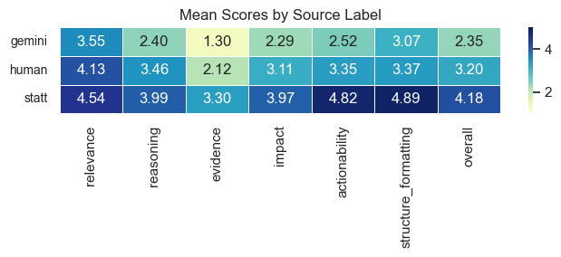
Figure 1. Mean scores heatmap by source — Round 1

4.2 Score Distribution
Figure 2 shows the distribution of overall scores. Statt comments are concentrated at 4–5, human comments span 2–5 with a median around 3–4, and Gemini comments are concentrated at 2–3, indicating systematically lower quality across the board.

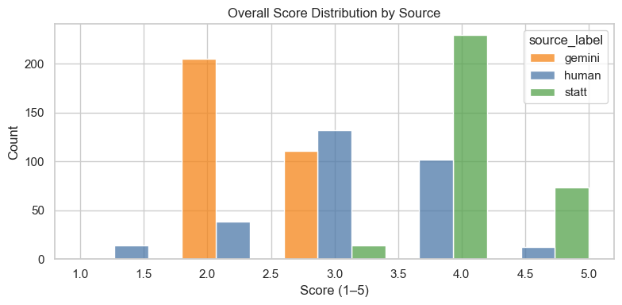
Figure 2. Overall score distribution by source — Round 1

4.3 Per-Criterion Breakdown
Figure 3 shows box plots for each criterion. Key patterns:
- Evidence is the weakest criterion for both human (2.12) and Gemini (1.30) comments, reflecting a general absence of data or citations. Statt scores considerably higher (3.30).
- Statt comments score markedly higher on Actionability (4.82) and Structure/Formatting (4.89), suggesting the platform's templated approach produces well-organized, recommendation-oriented output.
- Human comments outperform Gemini on Reasoning (3.46 vs. 2.40), Impact (3.11 vs. 2.29), and Actionability (3.35 vs. 2.52), indicating that real-world comments, while less polished, convey more substantive arguments.

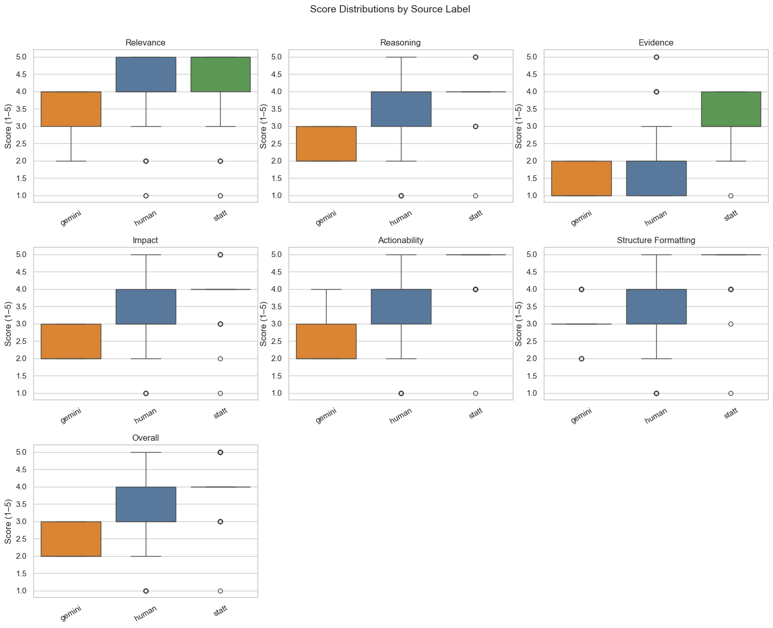
Figure 3. Score distributions by criterion and source — Round 1

4.4 Agency-Level Breakdown
Figure 4 shows mean overall scores broken down by agency and source. Statt consistently outperforms the other two sources across all three agencies (EPA: 4.23, FDA: 4.01, FMCSA: 4.27). Human comments score in the mid-range (EPA: 3.87, FDA: 3.28, FMCSA: 2.47), with FMCSA showing the largest gap to Statt. Gemini comments score lowest at all three agencies (EPA: 2.68, FDA: 2.09, FMCSA: 2.27).
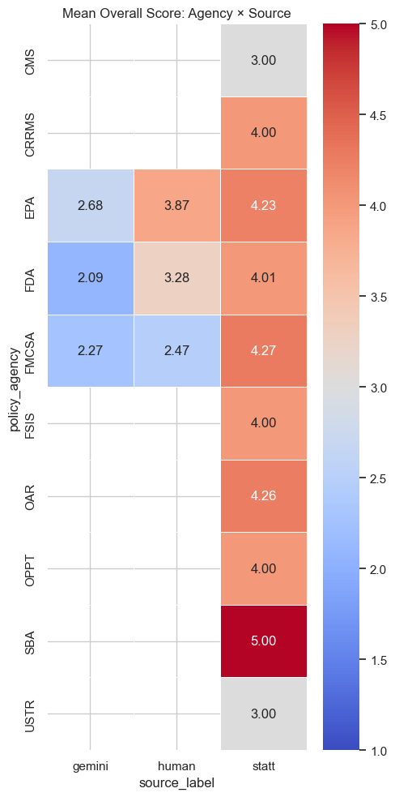
Figure 4. Mean overall score by agency and source — Round 1

4.5 Key Observations
- Statt-generated comments substantially outperform both human and Gemini comments across all criteria, achieving an overall mean of 4.18 versus 3.20 (human) and 2.35 (Gemini).
- Human comments are meaningfully better than Gemini-generated comments on most dimensions, particularly Reasoning, Impact, and Actionability — suggesting real-world comments carry substantive content despite weaker structure.
- The Statt advantage is largest for Actionability (Δ = 1.47 vs. human) and Evidence (Δ = 1.18 vs. human), reflecting the platform's structured generation approach.
- Evidence is universally the lowest-scoring criterion, pointing to a shared limitation across sources in substantiating claims with data or citations.
- Results are consistent across EPA, FDA, and FMCSA dockets, indicating findings are not specific to a single regulatory context.

5. Extension — Round 2: Expanded Human Corpus
To test robustness, the human corpus was expanded from ~298 to ~3,295 comments by adding approximately 3,000 comments collected directly from Regulations.gov. The AI comment sets (Statt and Gemini) remain unchanged.
As shown in Figure 5, the expanded human corpus yields markedly lower mean scores across all criteria — overall 2.31 vs. 3.20 in Round 1. This reflects the broader composition of public comments on Regulations.gov, which skews toward shorter, less substantive submissions relative to the curated Round 1 set. Despite this shift, the relative ranking across sources is preserved: Statt remains highest (4.18), followed by human (2.31), then Gemini (2.35 — now narrowly above the full human baseline).

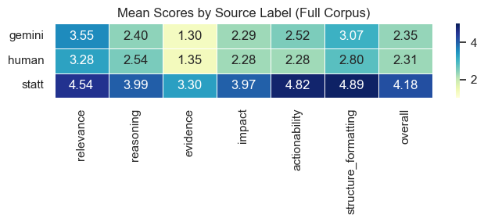
Figure 5. Mean scores heatmap by source — Full corpus (Round 2)

The Round 2 results confirm that the Statt quality advantage is robust: even as the human baseline adjusts to a more representative sample, Statt comments continue to score approximately 2 points higher overall. The main implication is that the Round 1 human corpus represents a relatively high-quality subset of public commenters, and the quality gap between Statt and a typical Regulations.gov submission is even wider than Round 1 suggests.

6. Discussion Points
- Interpretation of the Statt scoring advantage: to what extent do high scores reflect genuine comment quality versus conformance to a recognizable structure that the LLM evaluator rewards?
- Human comment variability: Round 1 and Round 2 human corpora differ substantially in quality (overall 3.20 vs. 2.31). What does this imply about the reference population for future comparisons?
- Validity of LLM-as-evaluator: methodological limitations and potential calibration against human expert ratings.
- Practical implications: how agencies might interpret or respond to a large influx of high-scoring, AI-generated comments relative to human submissions.

Prepared by the Prof. Michael Bailey’s Research Team at Georgetown University. For internal and discussion use only.

